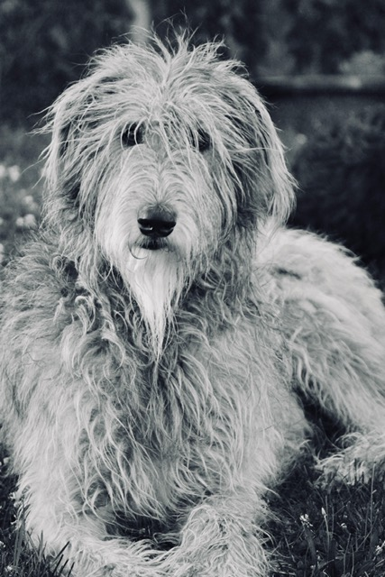
Gewels Memorial Scholarship Application 2021

Presented by Paws for a Cause PA

A $500 scholarship will be awarded to a graduating senior who has completed at least (10) hours of volunteer work related to or with animals. Applicants will be required to submit proof of volunteer hours with application. Hours must be verified by the head of the shelter/volunteer organization.

Applications are due to the High School Guidance Office, postmarked or delivered no later than Monday, May 3rd, 2021.
No late applications will be accepted.

Name:________________________________________________________________________
Address:______________________________________________________________________ ______________________________________________________________________________

Future educational plans (Do you plan to continue volunteer work? Are you interested in veterinary sciences?):
______________________________________________________________________________ ______________________________________________________________________________ ______________________________________________________________________________

Hours served volunteering with animals (shelters, veterinary, animal training, rescue group, etc):______________

List at least three references of character

Name Phone Number
______________________________ ______________________________
______________________________ ______________________________
______________________________ ______________________________
______________________________ ______________________________
______________________________ ______________________________

*Please attach a copy or copies of your volunteer hours to the application. Thanks and good luck!

Applications may be delivered to your school guidance office or mailed/ delivered to Paws for a Cause PA, 800 E. Grand Ave. Tower City, PA 17980.

